Chapter 10, Problem 46.

Solve for v_{o}(t) in the circuit of Fig. 10.91 using the superposition principle.

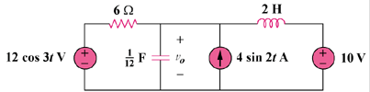

Figure 10.91
For Prob. 10.46.

